CASE STUDY 2: GENERESTA ENGINEERING CONSULTING
Workforce Demographic & Turnover Analysis
Case Study 2 | Southern Ontario Operations

Prepared by:
Group 4: Khang Nguyen, Yue Dong Pan, Mitchell Opeshansky

Objectives
This report presents a workforce analysis of Generesta Engineering Consulting, a medium-sized consulting firm based in Ontario with over 3,000 employees.
The analysis draws from two primary data sources, which are the Payroll Database and the Terminated Employee Database, and covers six core areas:
- Occupation and gender distribution across all roles
- Workforce demographics by gender, age, and employment status
- Voluntary and involuntary turnover trends from 2007 to 2010
- Leave of absence patterns by gender and reason code
- Retirement trends and knowledge continuity risk
- Strategic recommendations for company

The findings reveal an organization that is technically driven, male-dominated in engineering roles, and that weathered significant workforce disruption during the 2008–2010 economic downturn. Early retirement, long-term disability leaves, and gender gaps in technical roles are among the most pressing issues that require leadership attention going forward.

Company Overview
Generesta Engineering Consulting is a mid-sized professional services firm with a workforce of approximately 3,217 employees. Operating from its base in Southern Ontario, the firm delivers engineering and technical consulting across four key sectors of the Canadian economy, with additional project exposure in select northern U.S. states.

This workforce analysis was conducted using two core databases:
- Payroll Database Master.xlsx - containing active and current employee records including occupation, gender, age, and employment status
- Terminated Employee Database Master.xlsx - containing historical separation data including termination category, termination reason, and year

These datasets offer a detailed picture of company’s current workforce composition and employee movement trends.

Section 1: Occupation Distribution & Gender Breakdown

1.1 Occupation Distribution Overview

Occupation | Count | % of Workforce
Accounting | 165 | 5.1%
Analysts | 102 | 3.2%
Building Maintenance | 54 | 1.7%
Business Development | 107 | 3.3%
CEO | 1 | 0.0%
CFO | 1 | 0.0%
CHRO | 1 | 0.0%
CIO | 1 | 0.0%
Clerks/Assistants | 301 | 9.4%
COO | 1 | 0.0%
Co-op Students | 49 | 1.5%
Drafter | 301 | 9.4%
Engineer | 678 | 21.1%
HR | 49 | 1.5%
IT | 75 | 2.3%
Legal | 40 | 1.2%
Logistics | 73 | 2.3%
Managers | 100 | 3.1%
Procurement | 36 | 1.1%
Project Managers | 148 | 4.6%
Technician - Engineering | 284 | 8.8%
Trades | 646 | 20.1%
VP Civil Engineering | 1 | 0.0%
VP Construction Engineering | 1 | 0.0%
VP Mining Engineering | 1 | 0.0%
VP Utility Engineering | 1 | 0.0%
Total | 3,217 | 100%

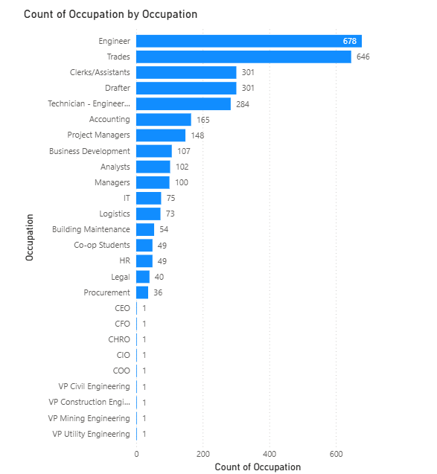
Figure 1.1 — Occupation Distribution (All Employees)

Key Observations
The occupation distribution chart shows that the largest employee groups are Engineers (678) and Trades (646). These two occupations represent a large portion of the total 3,217 employees, suggesting that the company is strongly focused on engineering and technical work. Other large groups include Clerks/Assistants (301), Drafters (301), and Technician – Engineering (284), which likely support engineering operations and projects.

Several mid-sized occupations such as Accounting (165), Project Managers (148), Business Development (107), Analysts (102), and Managers (100) help support business functions and project management. Smaller departments like HR, Legal, and Procurement have fewer employees but still play important roles in the organization.

Support functions - HR (49), Legal (40), Procurement (36), and Logistics (73) - are lean relative to the firm's size, which is consistent with the structure of consulting organizations that prioritize billable technical roles over corporate overhead.

1.2 Occupation by Gender

Occupation | Male | Female | Gender Ratio (M:F)
Accounting | 87 | 78 | 1.1:1
Analysts | 82 | 20 | 4.1:1
Building Maintenance | 34 | 20 | 1.7:1
Business Development | 72 | 35 | 2.1:1
Clerks/Assistants | 42 | 259 | 0.2:1
Co-op Students | 32 | 17 | 1.9:1
Drafter | 210 | 91 | 2.3:1
Engineer | 632 | 46 | 13.7:1
HR | 25 | 24 | 1.0:1
IT | 38 | 37 | 1.0:1
Legal | 19 | 21 | 0.9:1
Logistics | 65 | 8 | 8.1:1
Managers | 90 | 10 | 9.0:1
Procurement | 22 | 14 | 1.6:1
Project Managers | 76 | 72 | 1.1:1
Technician - Engineering | 259 | 25 | 10.4:1
Trades | 582 | 64 | 9.1:1

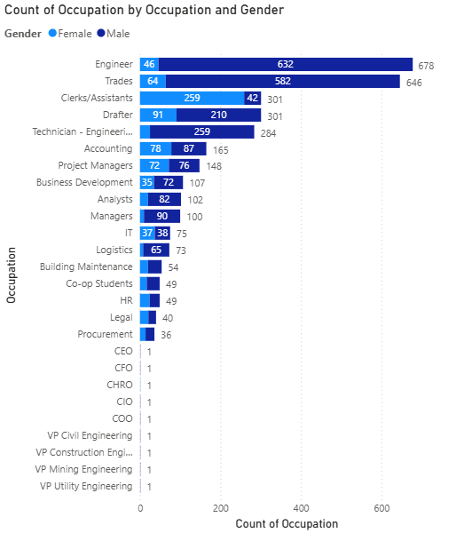
Figure 1.2 — Occupation by Gender (Stacked View)

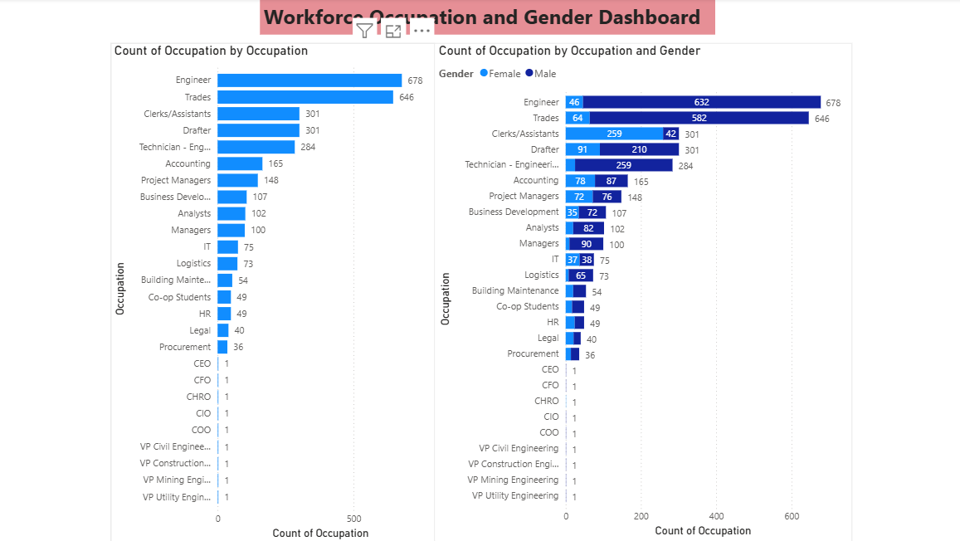
Figure 1.3 — Gender Distribution Across Occupations (Clustered Chart)

Key Observations
The gender distribution chart shows noticeable differences across occupations. Many technical roles such as Engineers, Trades, and Drafters are mostly male. For example, the engineering occupation has 632 male employees and 46 female employees, indicating a large gender gap in this field.

In contrast, some roles such as Clerks/Assistants have more female employees, with 259 females and 42 males. Other occupations such as Accounting, Managers, and Project Managers appear more balanced, although males slightly outnumber females in some cases.

Conclusion

Overall, the analysis shows that the organization is largely focused on engineering and technical occupations. The gender distribution also reveals that males dominate many technical roles, while females are more represented in administrative positions. These results provide useful insight into the company’s workforce structure.

Recommendation

Based on the analysis, the company should continue investing in recruitment and training for technical roles such as engineering and trades. The company could also consider initiatives to encourage more female participation in technical fields to improve gender diversity. In addition, regularly reviewing workforce data can help management better plan hiring strategies and maintain a balanced workforce in the future.

Section 2: Workforce Demographics - Gender, Age & Status
This section provides a demographic overview of Generesta's current workforce, covering three core dimensions: gender composition, age distribution, and employment status. The analysis draws from the Payroll Database and is visualized through a combined dashboard.

2.1 Gender Distribution
Gender | Count | Share (%)
Male | 2,375 | 73.8%
Female | 842 | 26.2%
Total | 3,217 | 100%

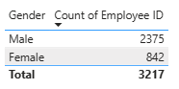
Figure 2.1a - Employee Count Table by Gender

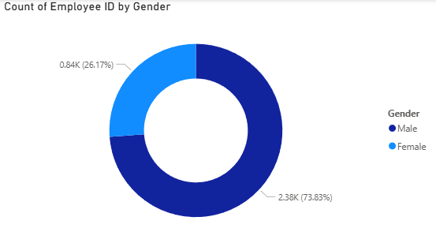
Figure 2.1b - Gender Distribution Donut Chart

Interpretation
The gender distribution chart shows the % and counts of male and female employees inside the organization. This particular business appears to contain a greater number of male employees than female employees. This pattern may reflect the demographic of engineering and consulting industries, where certain technical roles often have higher male representation.

2.2 Age Distribution

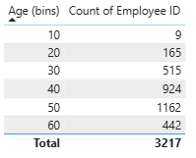
Figure 2.2a - Employee Counts by Age Bin (Table)

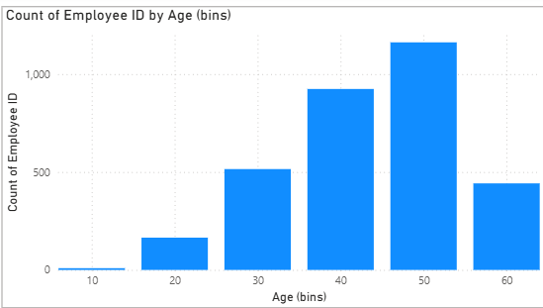
Figure 2.2b - Age Distribution Clustered Column Chart

Interpretation
This age distribution clustered column chart displays that the majority of employees fall within the mid-career age range between approximately 40 and 50 years old. This means that the company hires a workforce with considerable past professional experience. A smaller percentage of the company's employees belong to younger or borderline-retirement age groups.

2.3 Employment Status Distribution
Status | Count | % of Total
Active | ~2,972 | ~92.4%
Leave of Absence | 245 | 7.6%

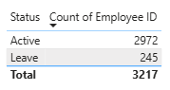
Figure 2.3a - Employee Status Counts (Table)

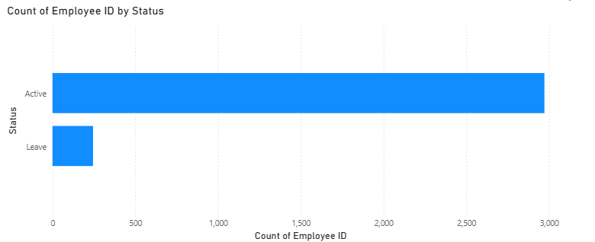
Figure 2.3b - Employee Count by Status Bar Chart

Interpretation
This chart displaying employee status distribution shows that most current employees are active inside the business. A substantially smaller portion (∼10x less) of employees fall under the leave of absence category. This indicates that this organization maintains a mostly active work staff by a large amount.

2.4 Combined Demographic Dashboard
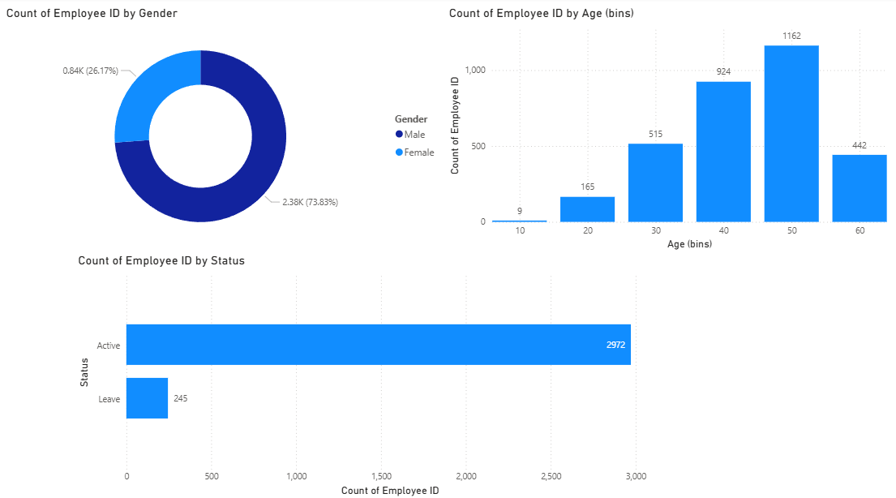
Figure 2.4 - Workforce Demographic Dashboard (Gender, Age & Status Combined)

To summarize the demographics analyzed in this business's workforce, most of the employees are in their 40s-50s, they mostly consist of men, and they are almost all active. Specific numbers can be found above.

Section 3: Turnover Analysis - Voluntary and Involuntary (2007–2010)

3.1 Turnover Hierarchy Framework
For this analysis, employee separations were organized into a two-tier hierarchy to allow for clear, comparable turnover rates by year:

- Core Turnover: Voluntary + Involuntary separations
- Other Separations (excluded from core turnover rate): Retirement, Death

3.2 Voluntary vs. Involuntary Turnover by Year
Year | Voluntary (%) | Involuntary (%) | Dominant Category
2007 | 92.4% | 7.6% | Voluntary
2008 | 82.7% | 17.3% | Voluntary
2009 | 19.8% | 80.2% | Involuntary
2010 | 15.4% | 84.6% | Involuntary

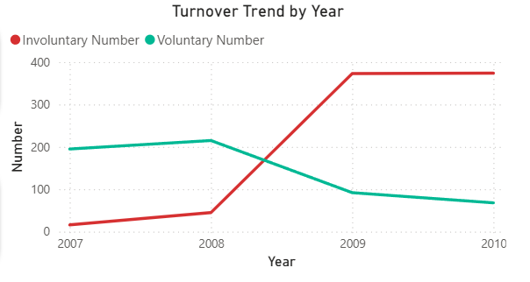
Figure 3.1 — Voluntary vs. Involuntary Turnover Share (2007–2010)

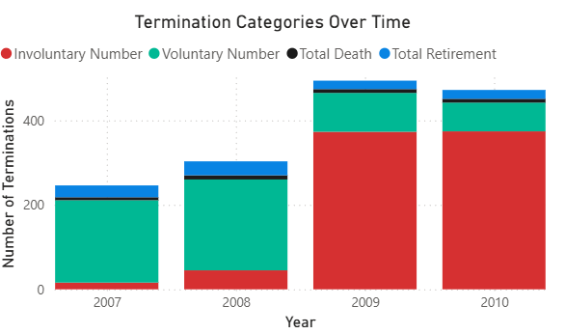
Figure 3.2 — Turnover Volume by Category and Year

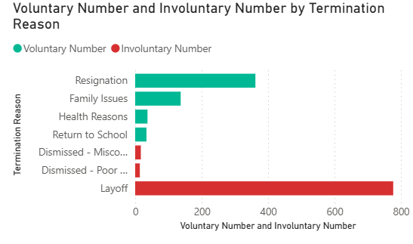
Figure 3.3 — Turnover Trend Line (2007–2010)

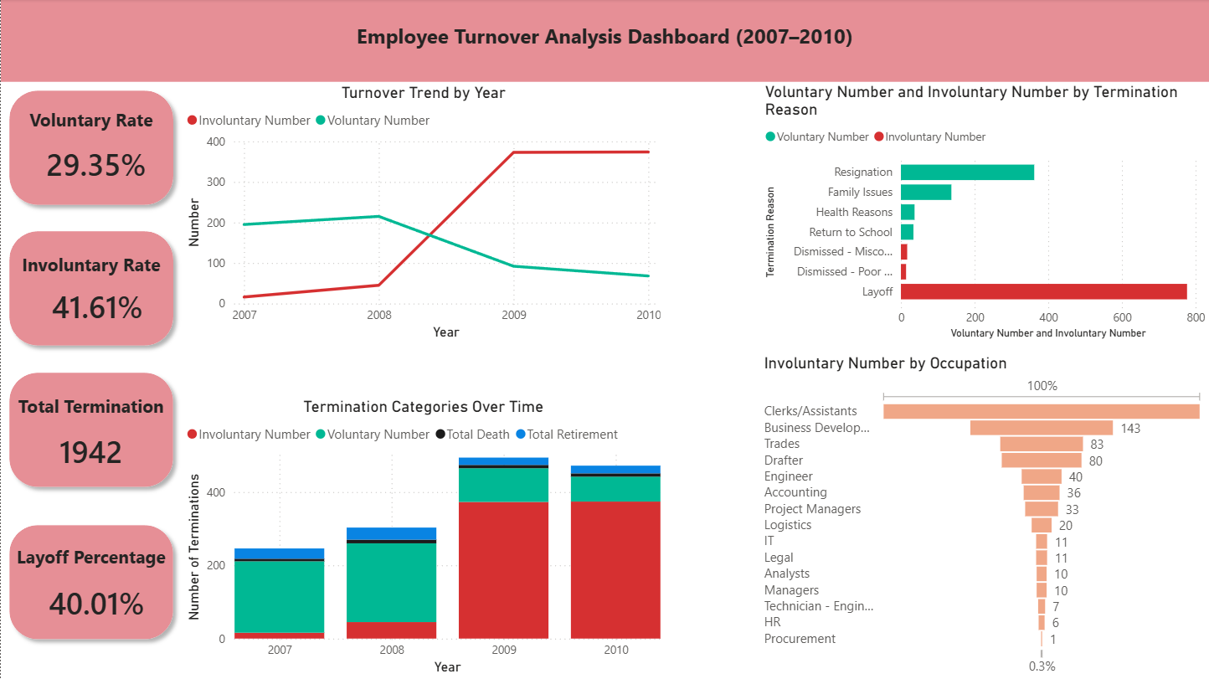
Figure 3.4 — Termination Reasons Dashboard

3.3 Top Termination Reasons
Termination Reason | Total Count
Layoff | 777
Early Retirement | 427
Resignation | 362
Family Issues | 137
Retirement | 102
Health Reasons | 37
Death | 35
Return to School | 34
Dismissed - Misconduct | 17
Dismissed - Poor Performance | 14
Total | 1,942

3.4 Interpretation

Pre-Crisis Period (2007–2008): Voluntary-Led Separations
A clear structural shift in employee separations is observed between 2007 and 2010.
Pre-crisis period (2007-2008)
During 2007, the workforce experienced very high voluntary turnover with 92.4% and minimal involuntary separation. This indicates a stable labor market, where employees primarily left the organization by choice.
In 2008, voluntary turnover remains dominant but begins to decline slightly. This aligns with the early stages of the 2008 global financial crisis, when organizations began preparing for economic uncertainty.

Crisis impact period (2009-2010)
The most dramatic change occurs in 2009, where involuntary separations surge to 80.2% of total turnover. This trend continues in 2010, where involuntary separations account for 84.6% of total turnover.
This shift strongly correlates with the global economic recession triggered by the 2008 financial crisis. Many organizations across industries responded with:
- cost-reduction strategies
- workforce restructuring
- hiring freezes
- large-scale layoffs
The dataset reflects these patterns clearly, as layoffs become the dominant termination reason, accounting for 777 cases, the highest among all separation categories.

Section 4: Leave of Absence - Demographic Analysis

4.1 LOA Population Overview
At the time of analysis, 245 employees (7.6% of the total workforce) are on a leave of absence. The leave population is categorized into three reason codes: Long-Term Disability (LTD), Sick Leave (SICK), and Maternity Leave (MATERNITY).

4.2 Gender Distribution: Workforce vs. LOA Population
The contrast between overall workforce gender composition and leave population gender composition is one of the most striking findings in this dataset:

Gender | Workforce Count | Workforce Share (%)
Male | 2,375 | 73.8%
Female | 842 | 26.2%

Gender | LOA Count | Share of LOA (%)
Male | ~114 | 46.5%
Female | ~131 | 53.5%

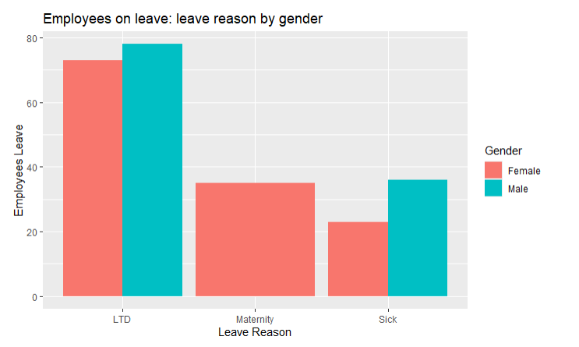
Figure 4.1 — LOA Gender Distribution vs. Overall Workforce Gender Composition

LOA distribution differs significantly from the overall workforce composition. Although females represent only 26.2% of the workforce, they account for over half of LOA cases, indicating gender-related leave patterns

4.3 Leave Reasons Breakdown
Leave Reason | Count | Share of LOA Population (%)
Long-Term Disability (LTD) | 151 | 61.6%
Sick Leave (SICK) | 59 | 24.1%
Maternity Leave (MATERNITY) | 35 | 14.3%
Total | 245 | 100%

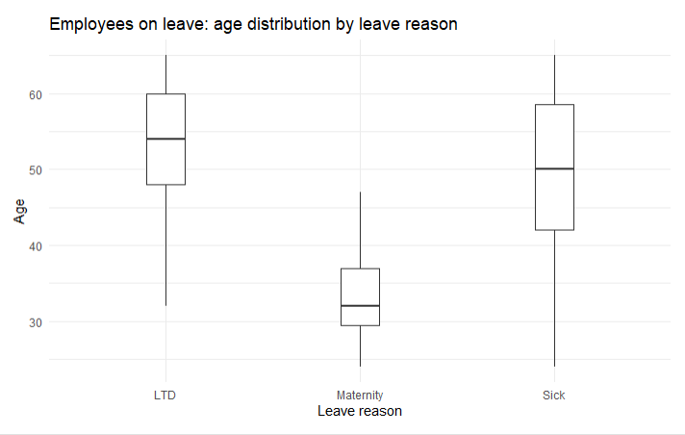
Figure 4.2 — LOA Population by Leave Reason (Bar Chart)

Key Findings
- The majority of leave cases (61.6%) are related to Long-term disability (LTD). This suggests that health-related absence is a major workforce management issue in the company.
- Sick leave represents approximately one-quarter of all leave cases, which may indicate:
- workplace health challenges
- occupational stress
- aging workforce effects
- Maternity leave represents 14.3% of leave cases, contributing to the higher female share of the LOA population.
- The boxplot analysis of age distribution also suggests that different leave reasons correspond with different employee age groups.

Section 5: Retirement Analysis - Last 4 Years

5.1 Overview
Retirement Type | Count | Share (%)
Early Retirement | 427 | 80.7%
Standard Retirement | 102 | 19.3%
Total | 529 | 100%

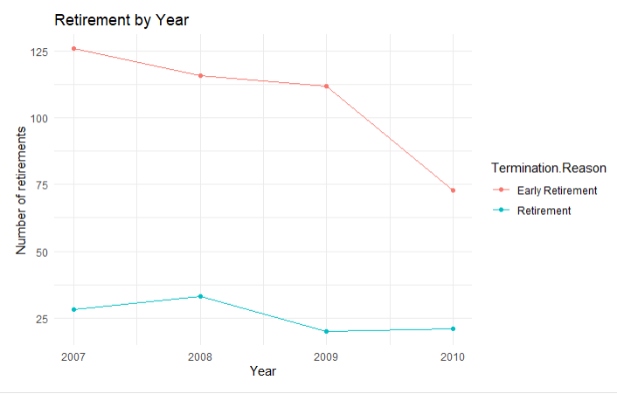
Figure 5.1 — Retirement Volume by Type and Year

5.2 Key Observations
Retirement volume declines over the 4-year period.
• Early retirement is the dominant retirement type, which may indicate incentivized retirement programs or workforce reshaping.
• Retirements are strongly associated with very long employee tenure, with an average of approximately 30 years of service.
- This indicates that retiring employees likely possess:
- Extensive organizational knowledge
- Deep technical expertise
- Leadership experience

Section 6: Recommendations
Based on the analysis conducted across all five preceding sections, the following recommendations are offered to the leadership and HR decision-makers at Generesta Engineering Consulting. These are intended to address both immediate operational risks and longer-term strategic workforce priorities.

Recommendation 1: Accelerate Gender Diversity in Technical Roles
The gender gap in engineering (14:1 male-to-female), trades (9:1), and technical roles is significant and out of step with evolving industry standards and talent market realities. A narrower talent pool limits the firm's ability to attract the best candidates and may affect client perceptions in an increasingly equity-conscious procurement environment.

- Partner with engineering faculties at Ontario universities (e.g., Waterloo, McMaster, Queen's) to create co-op and internship pipelines targeted at women in STEM.
- Review job postings and recruitment language to ensure they are inclusive and do not inadvertently discourage female applicants.
- Establish internal mentorship programs pairing female engineers and technical staff with senior leaders.
- Set measurable gender diversity targets for technical hiring over a 3–5 year horizon and report progress annually.

Recommendation 2: Develop a Formal Succession and Knowledge Transfer Program
With 529 retirements in four years - 80.7% of which were early - and an average retiring tenure of approximately 30 years, Generesta is at real risk of losing irreplaceable institutional knowledge. The current retirement trend, combined with the aging workforce (65% of employees aged 40–59), means succession planning is not a future consideration - it is an immediate operational need.

- Identify the top 100–150 roles most exposed to retirement risk within the next 5 years and map internal successors for each.
- Create structured knowledge-capture programs: documented processes, mentoring pairs, and project handover protocols.
- Consider phased retirement arrangements that allow retiring employees to reduce hours gradually, extending their availability as mentors and advisors.
- Introduce internal promotion pathways for mid-level technical staff to accelerate readiness for senior roles.

Recommendation 3: Address Long-Term Disability and Workplace Health
LTD cases account for 61.6% of all leave of absence instances. Given that trades and engineering roles involve physical work, this is not entirely unexpected - but the scale warrants a proactive health and safety response rather than a reactive one.

- Conduct a workplace ergonomics and occupational health review across field operations, particularly in trades and engineering technician roles.
- Invest in early intervention programs (physiotherapy access, mental health EAP services, early return-to-work programs) to reduce LTD duration and incidence.
- Track LTD cases by department and occupation to identify whether certain roles or worksites carry disproportionate risk.
- Review the total compensation package to ensure LTD coverage and sick-day banks are competitive and encourage early medical attention rather than delayed claims.

Recommendation 4: Strengthen Retention Strategies for Voluntary Turnover
While voluntary turnover dropped sharply during the recession years (2009–2010), it was the dominant mode of exit in 2007 and 2008. As the labour market recovers and tightens - particularly for skilled engineers and tradespeople - the risk of voluntary attrition rising again is real. Employees who left by choice in 2007 were likely responding to better opportunities elsewhere.

- Conduct structured exit interviews and an engagement survey to identify the root causes of voluntary departures, particularly among high-performers.
- Review compensation benchmarking against engineering consulting market rates annually - total compensation, not just base salary.
- Develop career ladders that make internal advancement visible and attainable for technical employees who may not aspire to management roles.
- Invest in professional development and continuing education subsidies, which are highly valued by engineers and knowledge workers.

Recommendation 5: Establish Return-to-Work Support for Leave Employees
245 employees are currently on leave, and the high rate of female LOA relative to their workforce representation points to a need for better leave lifecycle management — particularly for maternity leave and LTD returnees.

- Formalize a return-to-work program with flexible scheduling options for employees recovering from LTD or returning from parental leave.
- Ensure all managers receive training on accommodation obligations and return-to-work best practices under Ontario's employment and human rights legislation.
- Designate HR business partners responsible for proactive outreach to employees on extended leave, with check-ins at defined intervals.

